**Visvesvaraya Technological University, Belagavi – 590010**



**WEB TECHNOLOGY MINI PROJECT REPORT**

**ON**

**Notes Application**

***Submitted by***

Anson Dsouza

Milton Rodrigues

4SO17CS016

4SO17CS068

**Under the guidance of**

**Mr Karthik K**

(Assistant Professor, Department of CSE)



**DEPARTMENT OF COMPUTER SCIENCE AND ENGINEERING**

**ST JOSEPH ENGINEERING COLLEGE**

**Vamanjoor, Mangaluru -575028, Karnataka**

**2020-2021**

**ST JOSEPH ENGINEERING COLLEGE**

**(*Affiliated to VTU-Belagavi, Recognized by AICTE, B. E. (CSE) - NBA Accredited*)**

**Vamanjoor, Mangaluru- 575 028.**

**DEPARTMENT OF COMPUTER SCIENCE AND ENGINEERING**

**CERTIFICATE**



*This is to certify that the Mini project entitled* **“*Notes Application*”**

*is a bonafide work carried out by*

Anson Dsouza

Milton Rodrigues

4SO17CS016

4SO17CS068

*Students of seventh semester B.E. Computer Science & Engineering, and*

*submitted as a part of the course Web Technology Laboratory with Mini Project*

*(17CSL77), during the academic year 2020-2021.*

Staff In-Charge Head of the Department

**Examiners**

1.

2.

**ABSTRACT**

A notes application is a tool used to save notes, take reminders and keep essential information. It is an ideal tool to collect and manage all the personal and work-related notes. It can be also used to save text-based recipes, some daily routines in a list, grocery list, and it can also act as a to-do list. It is a great tool for organization. It increases productivity by listing the day’s work, forget the old pen and paper way of listing items, jot down ideas on the fly, make grocery list on the go and much more with Notes Application.

Apart from normal notes taking, the application also provides features to upload images, pdf, doc files, video files, audio files. This tool can also be used for creating articles since it supports multiple different types of files organized into a single block. The notes or article you create in your account can also be published, so that users having the account in this application will be able to view it. This tool can also be used as a backup for different types of files and the file can be accessed easily from anywhere since the application is deployed on cloud.

**ACKNOWLEDGEMENT**

We dedicate this page to acknowledge and thank those responsible for the shaping of the project without their guidance and help, the experience while constructing the dissertation would not have been so smooth and efficient.

We sincerely thank **Mr Karthik K, Assistant Professor**, Computer Science and Engineering for his guidance and valuable suggestions which helped me to complete the project.

We owe my profound gratitude to **Dr Sridevi Saralaya, Head of the Department,** Computer Science and Engineering.

We are extremely thankful to our **Director, Rev. Fr Wilfred P. D’Souza,** our **Principal, Dr Rio D’Souza,** and **Assistant Director, Rev. Fr Rohith Dcosta** and **Rev.Fr Alwyn Richard Dsouza** for their support and encouragement.

We would like to thank all our Computer Science and Engineering staff members who have always been with us extending their support, precious suggestions, guidance and encouragement through the project.

We also extend my gratitude to our friends and family members for their continuous support.

|  |  |  |
| --- | --- | --- |
| – | **Contents** |  |
| **SL NO.** | **TITLE** | **PAGE NO.** |
|  | Abstract | I |
|  | Acknowledgement | ii |
| 1. | Introduction | 7 |
| 1.1 | Purpose | 7 |
| 1.2 | System Overview | 7 |
| 1.3 | Problem Statement | 8 |
| 2. | Requirement Specification | 8 |
| 2.1 | User Characteristics | 8 |
| 2.2 | Functional Requirements | 8 |
| 2.3 | Non-Functional Requirements | 9 |
| 2.4 | Software Requirements | 9 |
| 3. | Design | 10 |
| 3.1 | Architectural Diagram | 10 |
| 4. | Screenshots | 12 |
| 5. | Conclusion and Future Work | 17 |
| 6. | References | 18 |

**FIGURE INDEX**

|  |  |  |
| --- | --- | --- |
| **SL NO.** | **TITLE** | **PAGE NO.** |
|  |  |  |

3.1.1 Structure of System 10

3.1.1 Work Flow Diagram 11

4.1 Home Page 12

4.2 Login and Signup 12

4.3 Create Note Page 13

4.4 Update Note content 14

4.5 View Note 14

4.6 Public Posts 15

4.7 Data Insights 15

**Chapter 1**

**INTRODUCTION**

* 1. **Purpose**

The main purpose of the application is to provide an easily accessible space for users to quicky write down their thoughts, plans or other information.

The information can be of any file type like text, audio, video, image which a user can store into this application in an organized way. The user will be able to access all the information from anywhere. Different files types can be stored into one particular block called article or a note. These notes can also be modified and updated according to user needs.

It also provides feature for a user to publish notes so that the user having the account in this application would be able to see it. Provides a interface to show all the different data files used for creation of users notes or Article

* 1. **System Overview**

This application has only client side as well as admin side. The client consists of actual application where a user can store or make his/her notes. The admin site can do modification to the database models or improve user interfaces.

There is a feature to publish the user article, so other users will be able to see it. The client side contains a feature to look into his or her data items used in the notes which are categorized into different sections based on its file type.

**1.3 Problem Statement**

To develop a Notes Application that helps users to keep notes, store different files as a backup related to one particular topic or thing into a block or say Article. The user can access the notes whenever required.

.

**Chapter 2**

**REQUIREMENTS SPECIFICATION**

**2.1 User Characteristics**

The website can be accessed by any user who has a browser and access to internet by typing the URL of the website in their search engine of choice. The application has a user authentication page for user to login, and has a interface to access all the notes that he has created. A functionality to update or delete the notes, categorize data files based on its types.

Also to make some notes public so that it will be available for other users too.

**2.2 Functional Requirements**

The website displays all the notes in the database created by the user. The notes can further be displayed to all the other users if it is made public. The user can contact the admin using the contact us page in the menu bar. The user will be able to do modifications to his content.

A functionality to keep track of all the files that are being used to make different note arranged based on category.

**1. Sign-Up:**

If the user wants to create his own blog posts then he has to sign up using the signup link in the menu bar and filling in the required details such as, full-name, username, Email, password.

**2. Login:**

The user can login if he has an existing account on the platform by clicking on the login link and then providing valid username and password.

**3. Create Notes:**

User who login can create their notes here, it provides fields title, description, image, video, audio, documents etc. This module also contains the feature to update, delete the create notes. All the notes created by the user can be accessed from here, by clicking on view post button which is place corresponding to the note title.

**4. View Post:**

It is used to get related files of a note, it displays title, description, video files, image files, audio files and a pdf document.

**5. Data Insights:**

This module is used to display all the files that a user has used in creating each note block. This is private to the user. The data here can be accessed in systematic way since it is made accessible in categories like images, docs, video and audio files.

**6. Publish:**

This is used to make some contents or the notes public, that is user logged into this system will be able to access all these notes if the notes is published. Notes or articles published by a user will be available to see in the “public post” module of the note. This module is used to contribute content to other users having account in this system

**7.Public Posts:**

This page contains posts from all the users having account in this application and have published the posts.

**2.3 Non-Functional Requirements**

The website shall be available to be accessed, provided the system resources are in proper working condition. The website shall be easy to browse through and shall not impose any inconvenience upon the user. The website shall not take an inconsiderate amount of time to load. The website shall not allow unauthorized access to the admin dashboard.

**1. Portability**

System running on one platform can easily be converted to run on another platform.

**2. Reliability**

The ability of the system to behave consistently in a user-acceptable manner when operating within the environment for which the system was intended.

**3. Availability**

The system should be available at all times, meaning the user can access it using a web browser, only restricted by the down time of the server on which the system runs.

**4. Maintainability**

A commercial database is used for maintaining the database and the application server takes care of the site.

**2.4 Software Requirements**

**Client Side:**

Browser: Google Chrome, Mozilla Firefox, Safari etc.

Built using: HTML, CSS, Bootstrap.

**Server Side:**

Database: SQLite3.

Framework: Django v3.1 Python Web Framework

.

Libraries: Asgiref v3.3.1, BeautifulSoup v4, TinyMCE v3.1.0, Pillow v8.0.1, Pytz, Soupsieve v2, Sqlparse v0.4.1.

IDE:Visual Studio Code.

**Chapter 3**

**DESIGN**

**3.1 Architectural Diagram:**

The structure of the system is divided into two components Client and server

**Client:** Users have to connect the server through the internet in order to use Notes App

**Server:** The web browser sends request to Notes database and database sends a response object

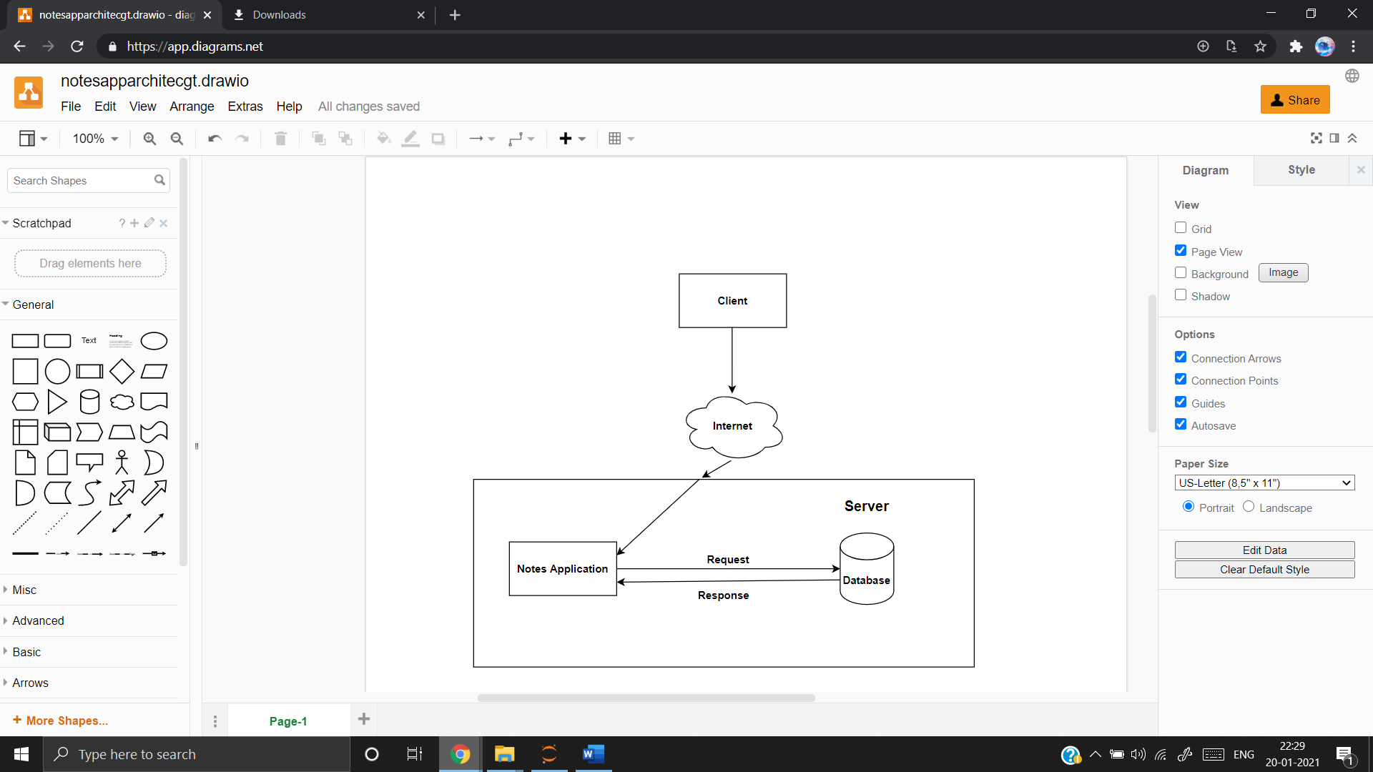

**Fig 3.1.1 Structure of System**

The Proposed system consists of a user module and admin module. In the user module, it contains a homepage, where the user needs to login and if he does not have credentials he needs to signup using the signup page

After login, the user can view his note and create note, update existing note. The user can add different file types in the note and can get the insight on the data that the user used for creating his note.

The user can make notes public and these notes can be viewed by other users logged into the system.

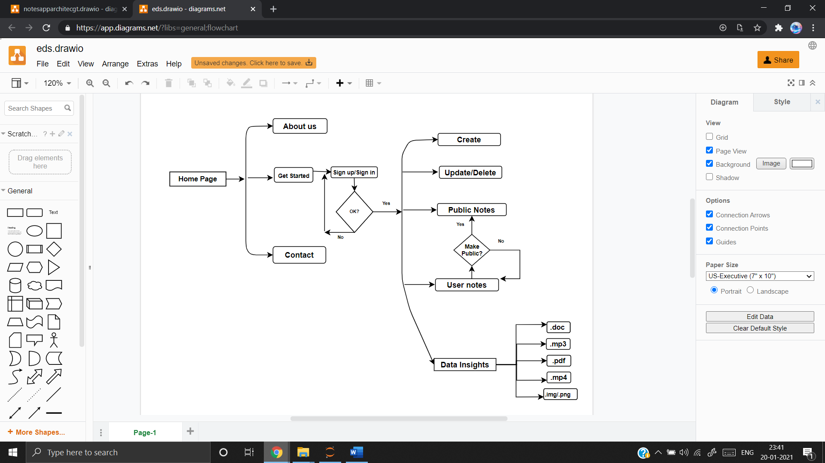

**Fig 3.1.2 Workflow Diagram**

**Chapter 4**

**SCREENSHOTS**

**4.1 Home Page**

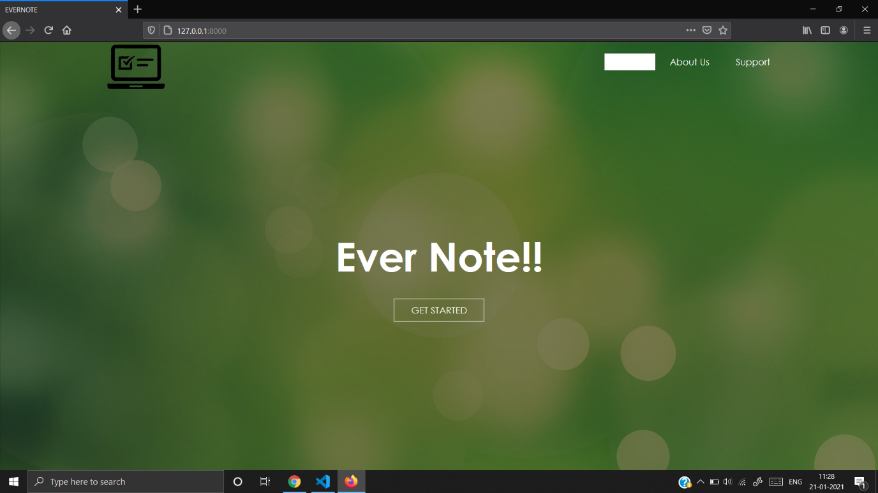

**4.2 Login and Sign up**

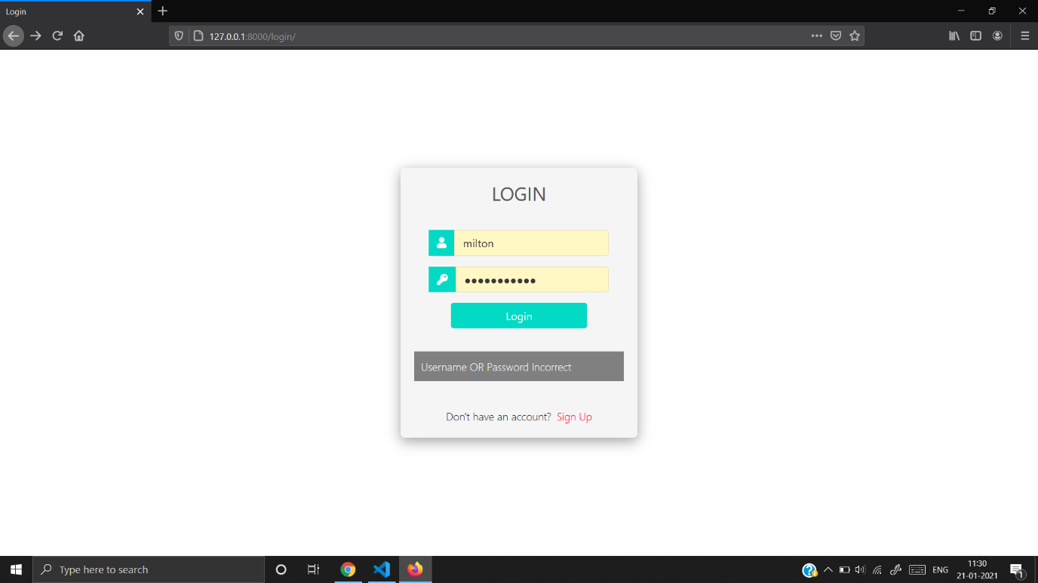

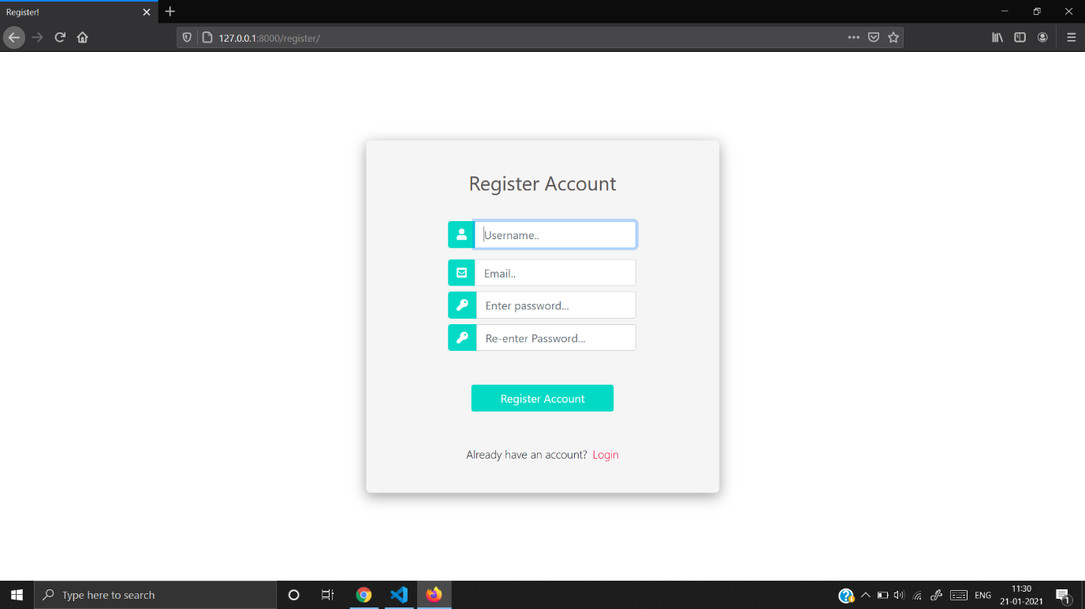

**4.3 Create Page and All Note View**

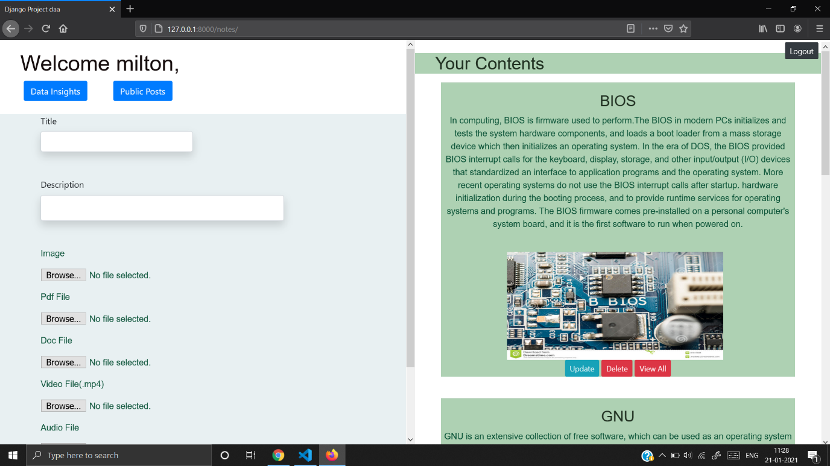

**4.4 Update Note Content**

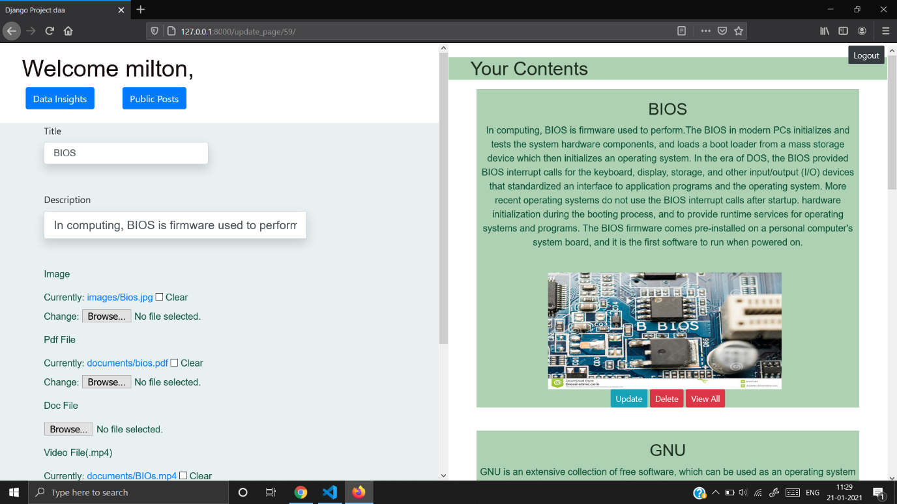

**4.5 View Notes**

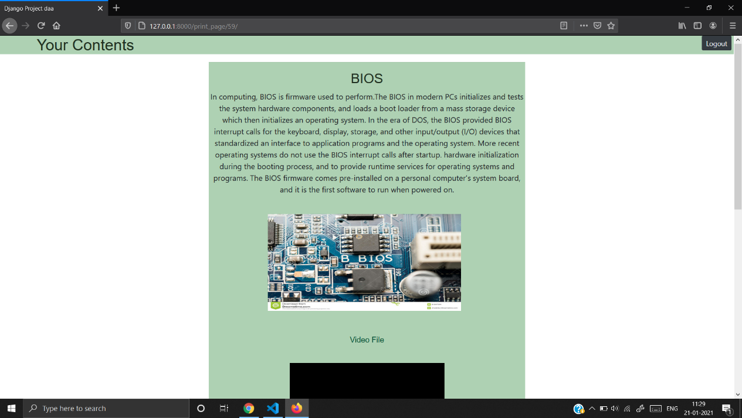

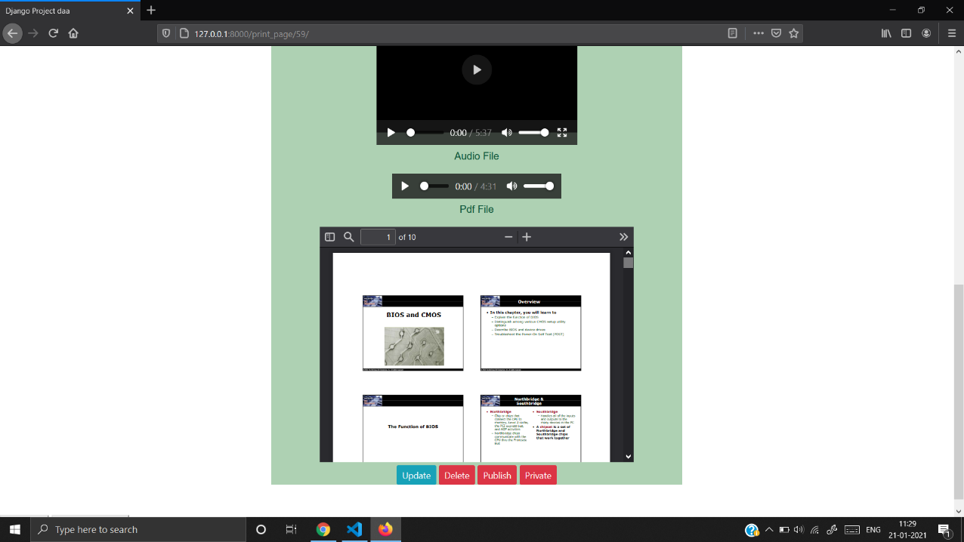

**4.6 Public Posts**

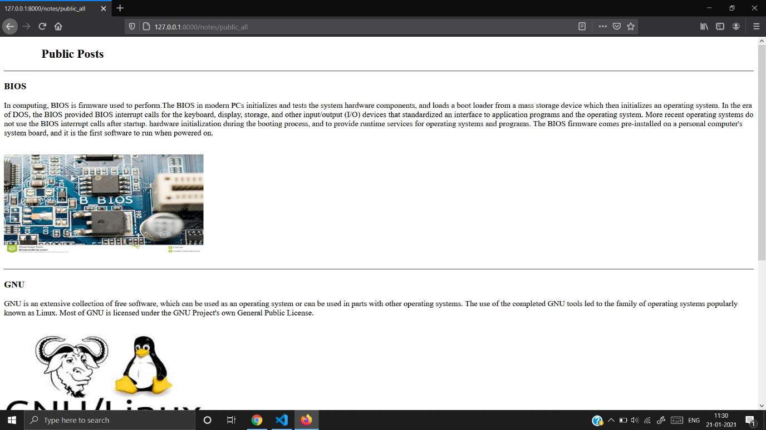

**4.7 Data Insights**

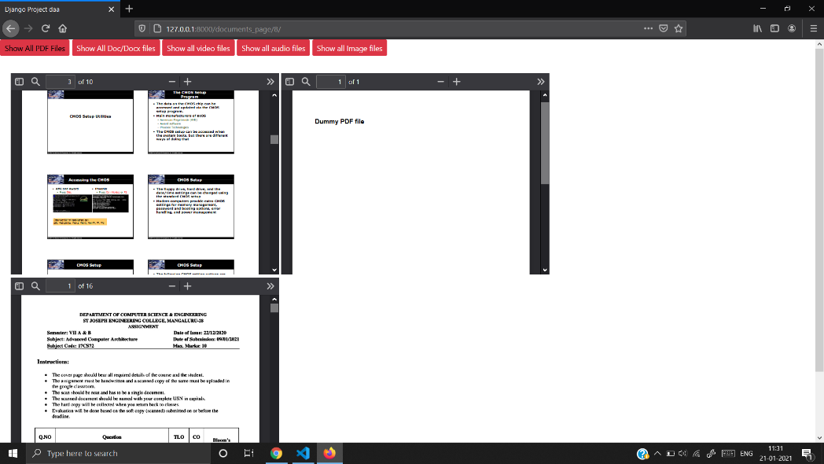

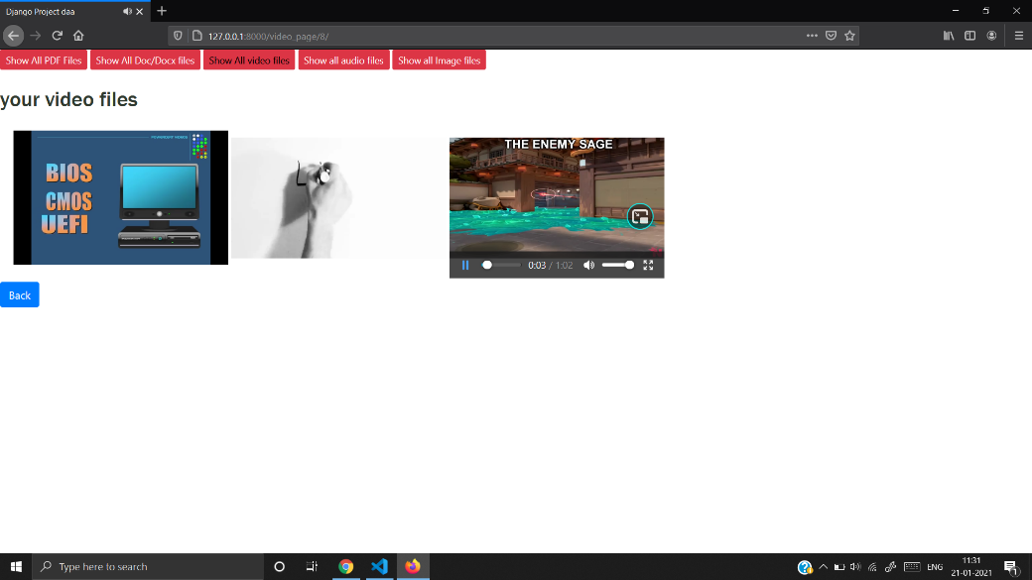

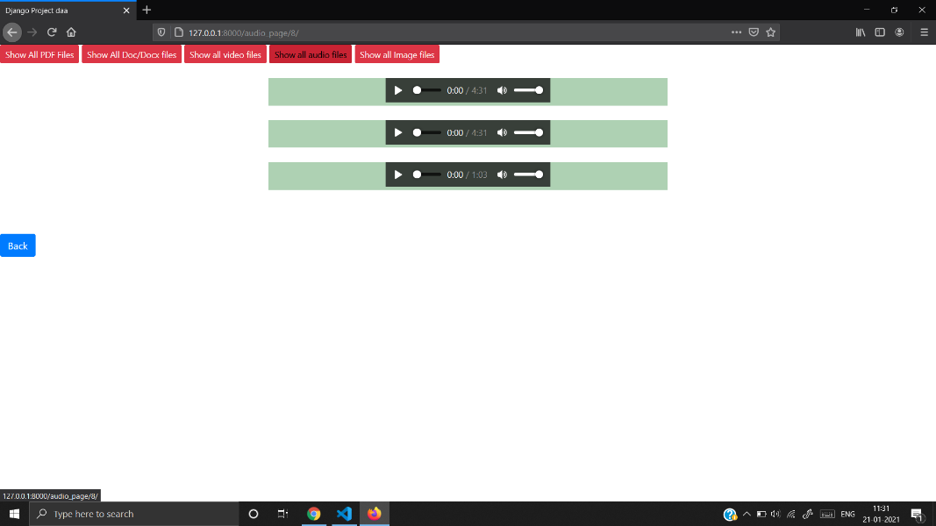

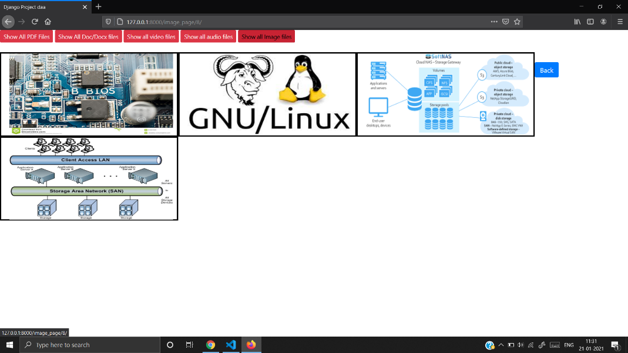

**Chapter 5**

**CONCLUSION AND FUTURE SCOPE**

The primary goal of this project is to implement Notes Application which allows users to store information and retrieve them. This application can also be used as a backup and easy access. We intend this website will be put to good usage and will help users with right information. This application helps to post personal content on different topics. When published the users having account in this application can access those content. The application also has feature to get the insights on different data that are used for creating notes.

The future scope of the project will include a feature to include comments where users can write comments on the public post and module forgot password in case users want to reset their passwords.

**REFERENCES**

* <https://evernote.com/>
* <https://jsuryakt.pythonanywhere.com/>
* <https://simplenote.com/>